INDEX
SR.NO | TOPIC | PAGE NO
1. | What is DevOps | 2
2. | The Old School: Waterfall Model | 3
3. | The Shift: Agile Model | 4
4. | Waterfall vs Scrum | 4
5. | The Big Picture: DevOps vs. Agile | 5
6. | Top Important Points (Summary) | 6

  - WHAT IS DEVOPS?

If there is one thing you need to take away from my 2+ years in this industry, it is this: DevOps is NOT a tool. You cannot buy "DevOps" in a box.
. DevOps is a Culture: It is a mindset shift. It’s about breaking down the walls between the people who write the code (Dev) and the people who keep the servers running (Ops).
. The Goal: To develop, release, and maintain software faster, but without breaking everything in the process. We want high quality at high speed.
. The "How": We achieve this culture by leaning heavily on Automation Tools. If you do it twice, automate it.
In the traditional world (before DevOps), a company was usually split into silos:
1) Development Group
2) Operations Group

Let's break down who actually sits in these groups in a real company:
A) Development Group (The "Makers"):
These folks build the product.
- Planning & Analysis : Business Analysts (BA), System Analysts (SA).
- Construction : Developers, Architects, Coders.
- Verification : QA Engineers, Testers, Build Engineers.

B) Operations Group (The "Keepers"):
These folks keep the lights on and the application alive.
- Provisioning : System Admins, Network Admins.
- Data Management : Database Admins (DBA).
- Release & Maintain : Release Engineers, SREs (Site Reliability Engineers).

The Problem:
Historically, Devs wanted change (new features), and Ops wanted stability (no changes). This conflict created a "Wall of Confusion." DevOps bridges this gap.

1.2) THE OLD SCHOOL: WATERFALL MODEL
To understand why we need DevOps, you have to look at where we came from. For a long time, we used the SDLC (Software Development Life Cycle) in a linear way, like a waterfall cascading down.
The Flow (Linear Sequential Model):
Requirements -> Analysis -> Design -> Coding -> Testing -> Release -> Maintenance
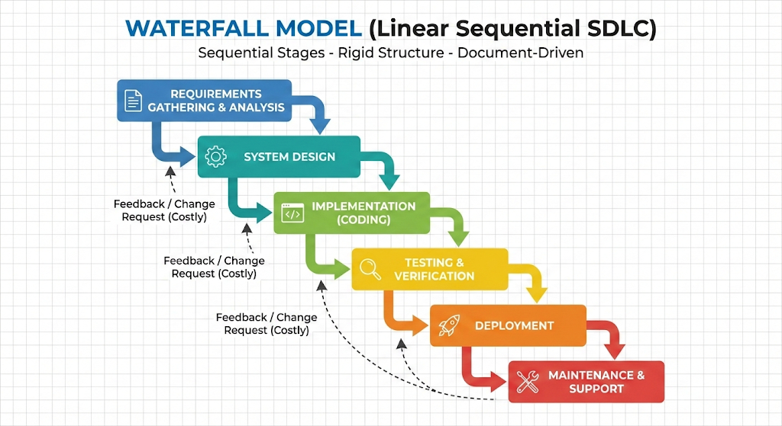

Advantages (Why we used it):
- Simple and disciplined. Everyone knew their place.
- Good for small projects with fixed, unchanging requirements.
- Easy to manage if you are a strict manager.

Limitations (Why we stopped using it):
- Slow to Market: You might code for 6 months before testing. By the time you release, the market has changed.
- High Cost of Bugs: If you find a bug in the "Testing" phase that was caused by a bad "Requirement," you have to go all the way back up the waterfall. That is expensive.
- No Flexibility: The client doesn't see the product until the end. If they don't like it, you're in trouble.
1.3) THE SHIFT: AGILE MODEL
Around the early 2000s, we got tired of waiting 6 months to see software. We moved to Agile.
- Agile is about Speed and Iteration.
- Instead of one big release, we break the product into small pieces.
- There are many "flavors" of Agile:
1. SCRUM (The most popular - heavily used today)
2. XP (Extreme Programming)
3. Kanban
4. FDD (Feature Driven Development)

SCRUM
- Derived from the game of Rugby (where the team moves the ball together).
- It is Iterative: We work in cycles called "Sprints."
- The Sprint: Usually 1 to 3 weeks long.
- The Team: A small, cross-functional group (7-9 people).
- The Result: At the end of every sprint, we have a working piece of software.

1.4) WATERFALL VS. SCRUM

Feature | Waterfall | Scrum (Agile)
Approach | Linear / Sequential | Iterative / Incremental
Flexibility | Rigid (Fixed Requirement) | Flexible (changes welcomed)
Delivery Time | Long (Months / Years) | Short (weeks)
Risk | High (Bing Bang Release) | Low (Fail fast, fix fast)

1.5) THE BIG PICTURE: DEVOPS VS. AGILE

This is where many people get confused. Is DevOps just Agile? No.
"Agile fixes the gap between Client and Developer. DevOps fixes the gap between Developer and Operations."

Similarities:
1. Both aim for rapid delivery.
2. Both rely on collaboration rather than documentation.

Differences (The Real-World View):
1. Scope:
- Agile stops when the code is written and tested (Development focus).
- DevOps picks up the baton and ensures that code runs in production reliably (End-to-End focus).

2. The Role:
- In pure Agile, you have a Developer and a Tester.
- In DevOps, we aim for the "Generalist." A DevOps engineer understands the code, the build, the
test, the server, and the cloud. You are the glue.

3. Automation:
- Agile encourages speed, but you can do Agile manually if you really want to.
- DevOps implies Automation. You cannot do DevOps without CI/CD pipelines, Infrastructure as Code
(IaC), and monitoring tools.

4. Feedback Loop:
- Agile feedback comes from the Client ("I don't like this button").
- DevOps feedback comes from the System ("This button is causing High CPU usage").

1.6) TOP IMPORTANT POINTS ABOUT DEVOPS (SUMMARY)

If you are sitting in an interview or explaining this to a CEO, here is your cheat sheet:
1) Not just a Tool: DevOps is a culture. Tools (like Jenkins, Docker, Kubernetes) are just the way we implement the culture.
2) The Goal is Collaboration: It kills the "blame game" between Devs and Ops.
3) Automation is King: If it's manual, it's a mistake waiting to happen. We automate Build, Test, Deploy, and Infrastructure.
4) The "Generalist" Engineer: A DevOps engineer is an all-rounder. You might not write the Java code, but you know how it compiles. You might not build the server rack, but you know how to spin up an AWS instance.
5) Continuous Everything: It is an infinite loop. Continuous Development -> Continuous Testing -> Continuous Deployment -> Continuous Monitoring.
6) Quality AND S peed: Agile promised speed. DevOps promises speed with stability.

